Lake Placid After School Program
Parent Handbook
PO Box 965, Lake Placid, NY 12946
518-524-2468
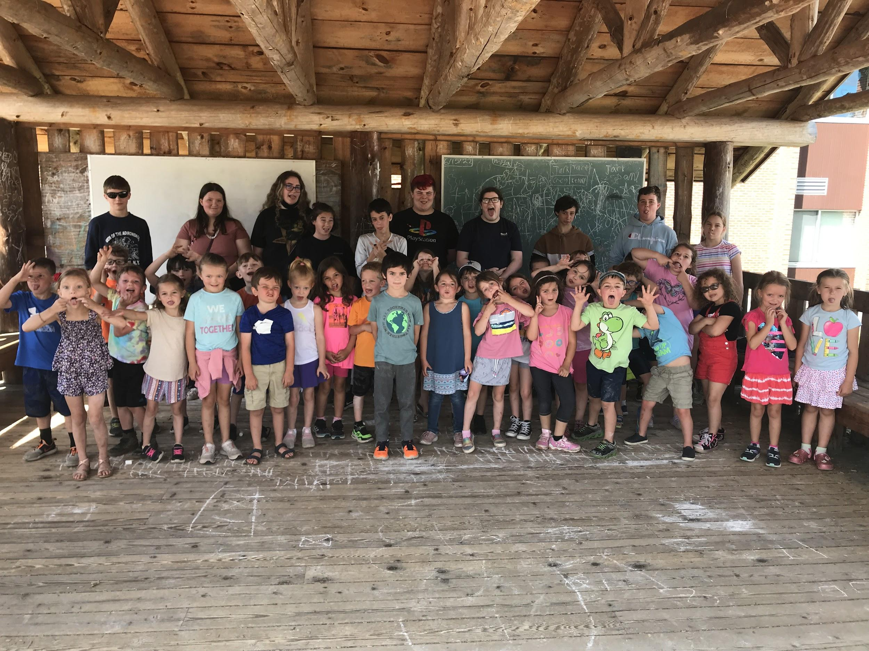
**Please read carefully**

Building a Better World One Student at a Time.

2022/2023
Please remember to sign and return the affidavit on the last page.
518-524-2468

Dear Guardian(s),

We are so excited to welcome the students back in just a few weeks!

To start the school year, we will be offering the program to full-time and part-time students, no drop ins. We also ask that part-time students commit to specific days, students will not be able to attend on days that they have not been signed up for. We hope to add flexibility back to part-timers and allow drop-ins as the school year progresses. We know this will affect many of our families and we apologize but it is with the best intentions for all involved.

This handbook is designed to give you a helpful insight into the After School Program. It includes detailed information about After School Program activities, procedures, and policies. Please read this handbook carefully and keep it in a safe place for easy reference during the school year.
The After School Program strives to provide an atmosphere where children can enjoy, grow, and learn. The staff always welcomes suggestions and ideas that will help us to make your child’s time at the After School Program beneficial and rewarding. We encourage you to share your thoughts and ideas with us at any time.
Many thanks go to the Lake Placid After School Program Board for their ongoing commitment to the After School Program, to the Lake Placid Elementary School for housing the Program, to the staff of the After School Program for their energy and the outstanding job they do with the children each and every day, and to the parents and guardians of the children in the After School Program for their continued support and encouragement. The children benefit greatly from the many special qualities contributed to the After School Program by so many wonderful and caring people!
If you have any questions about the content of this handbook, please feel free to call me at 518-524-2468 or email me at cshipman@lakeplacidcsd.net.
I look forward to the time that we will be spending together.
Sincerely,
Program Director, Cameron Scsigulinsky

2022/2023
Please remember to sign and return the affidavit on the last page.
518-524-2468
Policies & Procedures
GENERAL:
The Lake Placid After School Child Care Program is a licensed, non-profit community care program run by the Lake Placid Child Care Committee Inc. (LPCCC), a non-profit organization. All children from the Lake Placid School District in grades K-5 are invited to attend. Lake Placid After School Child Care Program is located in the cafeteria of the Lake Placid Elementary School.

The program calendar generally conforms to the Lake Placid Central School calendar. It begins on the first day of school & ends on the last day of school. The Program is closed on snow days, school holidays, and Superintendent Conference Days as noted on the LPCSD calendar. We will be bringing back half-days, in which we will take planned field trips.

Our child/staff ratio is one teacher for every 10 children each day. The program is based on safety, fun, and a curriculum of learning for the age groups present as required within the guidelines of the Department of New York State Family and Children’s Affairs. This program is open to all children of U.S. Citizenship without regard to race, religion, or national origin.

In an effort to be “Green” we will utilize email, social media and/or phone calls to notify parents of program changes.

REGISTRATION:
A completed application is needed prior to your child attending the after school program. You may obtain an application by downloading one from the school website under after school program, picking one up next to the elementary school office, or by calling the director and one will be mailed to you. *Note your child(ren) will not be able to attend if you have a past-due balance from the prior school year.

FEES: Registration Fee: $25.00 per child (non-refundable)
****We are not offering a drop-in option as of right now.***

WEEKLY CHARGE:
Daily charge per child: 1st child $15.00, 2nd child $11.00, 3rd child $7.00
Weekly Rate: (4-5days) 1st child $70.00, 2ndchild $50.00, 3rd child $30.00.

PAYMENT SCHEDULE: Billing statements are e-mailed or mailed depending on your preference monthly; they can not be split and are the responsibility of the guardian(s) who signs the application.
- Checks: Make payable to the Lake Placid Child Care Committee (LPCCC) and may be mailed to the Lake Placid Child Care Committee, PO Box 965, Lake Placid, NY 12946 or hand-delivered to a staff member.
- Credit Card: For your convenience, we accept credit card payments. Please see the attached form.
*WE STRONGLY ENCOURAGE THE USE OF A CREDIT CARD*
If payment difficulties appear imminent, please contact the LPCCC Director to arrange appropriate payment options. The After School Program reserves the right to impose a $10.00 late payment penalty per month delinquent or to revoke the enrollment of any child whose account is past due. * This is will not be an issue if a credit card is present*
*Communication is the key to understanding. If you let the director know what is going on, she may be able to help.
HOURS: Monday through Friday, 2:50 pm-5:30 pm*
All children must be picked up by 5:30 pm to prevent late fees.
*Our staff’s workday concludes at 5:30 pm, and they too, have personal and home obligations they must attend to, therefore, it’s important for parents to be on time. Nevertheless, if you should run late we would appreciate a call and a staff member will remain with your child until they are picked up. Regrettably, though, we must impose a “late fee”.
There is a late fee of $5.00 from 5:30 pm – 5:45 pm, plus $5.00 for every five minutes thereafter. Please note that if you are chronically late we may be forced to remove your child from the program.

PICK UP: Children are released only to parents, legal guardians, or persons authorized on the registration form. Written consent must be given if the child is to leave the program with another person. The program is not responsible for the child while traveling to and from the program unless on program-sponsored outings.
Parents may pick up their children by using the side door by the cafeteria, the playground in the rear, or through some other arrangement.
ATTENDANCE: Attendance is kept and checked daily. The safety of your child is paramount to the After School Program. Please make sure notes are clearly marked for the After School Program.
PROGRAM ACTIVITIES: Daily activities include homework time, snack, and indoor/outdoor activities. Children go outside daily except in inclement weather.
Our program focuses more on social and physical elements rather than academics. We find that this approach works best for our students. Mentoring, good citizenship, respect for ourselves, others, and fair play will be promoted daily.
COMING AND GOING: At the end of the school day, children will be released by a school announcement or by their teacher. If they are in kindergarten, a teacher will accompany the children to the cafeteria, where our day begins. If your child is in 1st -5th grades they will be released following the announcements or their teacher’s instructions. Again, notes need to be sent to school so your child goes to their intended location.
HOMEWORK POLICY: The After School Program stresses the importance of homework and sets time aside every day for children to complete their assignments. Staff members are available to supervise the homework area and to assist the children with their work, however, a child who needs individual help with his or her homework must ask. (Because of the number of children who require assistance during homework time, the staff members are unable to check each child’s homework for accuracy or provide the type of one-on-one homework help that is available from a private tutor.) Although we encourage the children to do their homework when it is assigned, using the time set aside to complete homework is the responsibility of the child. Please let us know if you prefer to have your child complete his or her homework at home. Children who do not wish to use homework time to complete their homework will use the time to read a book.
SNACK: We provide a wide variety of fresh food that meets the nutritional standards necessary for a child to thrive. We work closely to assure that children with food allergies have the same quality of healthy foods that meet their own special dietary needs. We encourage all children to try our snack before they refuse it. If your child has any food allergies, dietary restrictions, or prefers different or additional food, please feel free to send a snack to school with your child.
Personal water bottles and personal healthy snacks are allowed.
DISCIPLINE: Care and attention to the individual child is the core of our program. Following the rules of the Lake Placid Elementary School Handbook and other site-specific rules will aid in maintaining a safe and fun environment. Should the need arise, the following discipline procedures will be followed
✓ The child will be given a warning.
✓ Child will be given a time out.
✓ Parents will be notified of behavior and it will be documented.
A child may be suspended for days, weeks or permanently, depending on the severity of the behavior. Physical aggression against other children or counselors, or running away from program activities may result in immediate suspension.
The safety, care, and well being of the child are of utmost importance. *No violent or threatening toys, activities, or actions will be allowed. Special consideration to the space allowed by the Lake Placid Schools, staff, and crew will be in effect. Damage of any kind will not be tolerated and the areas inside and outside will be kept in proper order.
A quiet, positive, and smooth resolution to any difficulties involving a particular child is a priority. The program does, however, reserve the right to dismiss a child from the program if the negative actions continue, endanger their well-being, or that of another.
FIELD TRIPS: We are excited to implement field trips back into the program this year. Space for field trips is limited and sign-up for field trips will be sent out via email a few weeks before the trip. Types of field trips vary from apple picking to ice skating in the winter. Parents will be kept informed about the status of field trips.
BOARD OF DIRECTORS: The LPCCC Board provides valuable feedback, guidance, and support to the Program Director and staff. The Board is composed of: President- Julie Lawrence, Vice Pres.-Harrison Sangster, Treasurer- Francine at Meister Accounting -Secretary-Reilly Gadwaw, Members at Large- Andrea Barry, Anna Cunnniff, Sam Ano, Jamie Mercier, and Kristen Boslet
Program Director: Cameron Scsigulinsky: 518-524-2468 / cshipman@lakeplacidcsd.net
COMMUNICATION: The After School Program maintains an open door policy. Please feel free to direct questions or concerns related to any facet of the After School Program to the Program Director at any time. You may call, email, send a note, or request time to speak face to face. Any questions regarding tuition,
policies, staffing, activities, or a child’s participation in the Program may be directed to the Program Director at 518-524-2468 or at cshipman@lpcsd.org
CLOTHING: Since the children go outside daily (except for inclement weather), occasionally use the gym and offer messy art activities, you may want to send play clothes corresponding to the weather in your child’s backpack each day. Please be sure to send hats, mittens, boots, and snow pants in the winter. Please also make sure your child’s name is in each piece of clothing so it can be returned if misplaced. Masks will be required at the Program so you may also want to send an extra in your child’s backpack.
MANDATED STATE REPORTING TO SUSPECTED ABUSE: Under the New York State Child Protective Services Law, all After School Child Care Providers are listed as mandated reporters. This means that the LPCCC is required by law to report any suspicions of child abuse or neglect to the New York State Central Registry.
STATE CENTRAL OFFICE REGISTRATION: In accordance with the NYS law and for the protection of the children, all LPCCC employees must be cleared with the NY State Central Register of Child Abuse and Maltreatment to determine if he or she is the subject of an indicated child or maltreatment report. All employees must sign a statement informing the LPCCC of whether or not they have ever been convicted of a crime. All staff are fingerprinted in accordance with NYS law.
INSPECTION: The LPCCC agrees to allow the New York State Department of Social Services to access the program for inspection whether scheduled or unannounced at any time.

